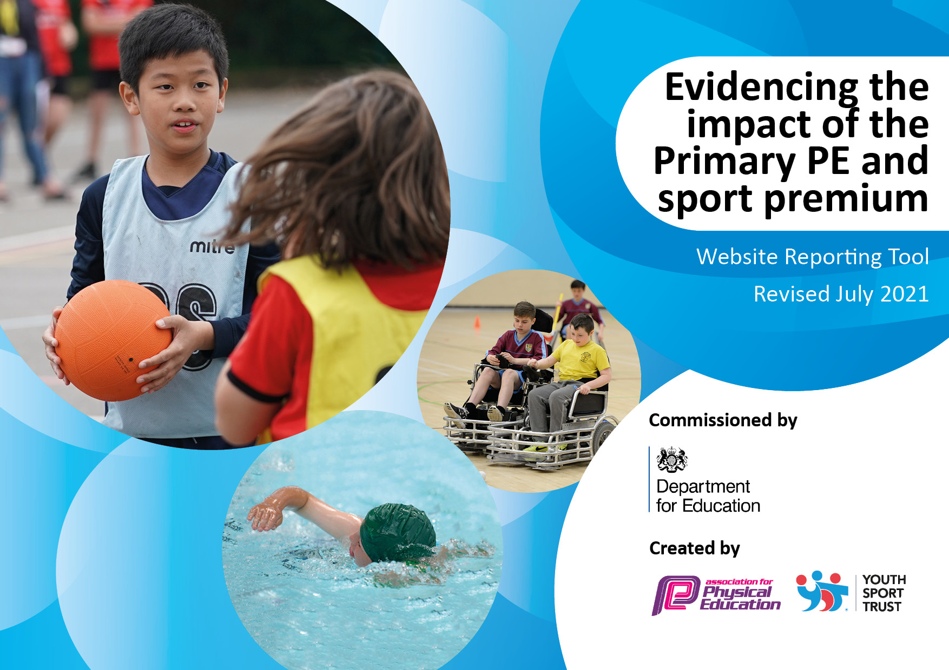
2023
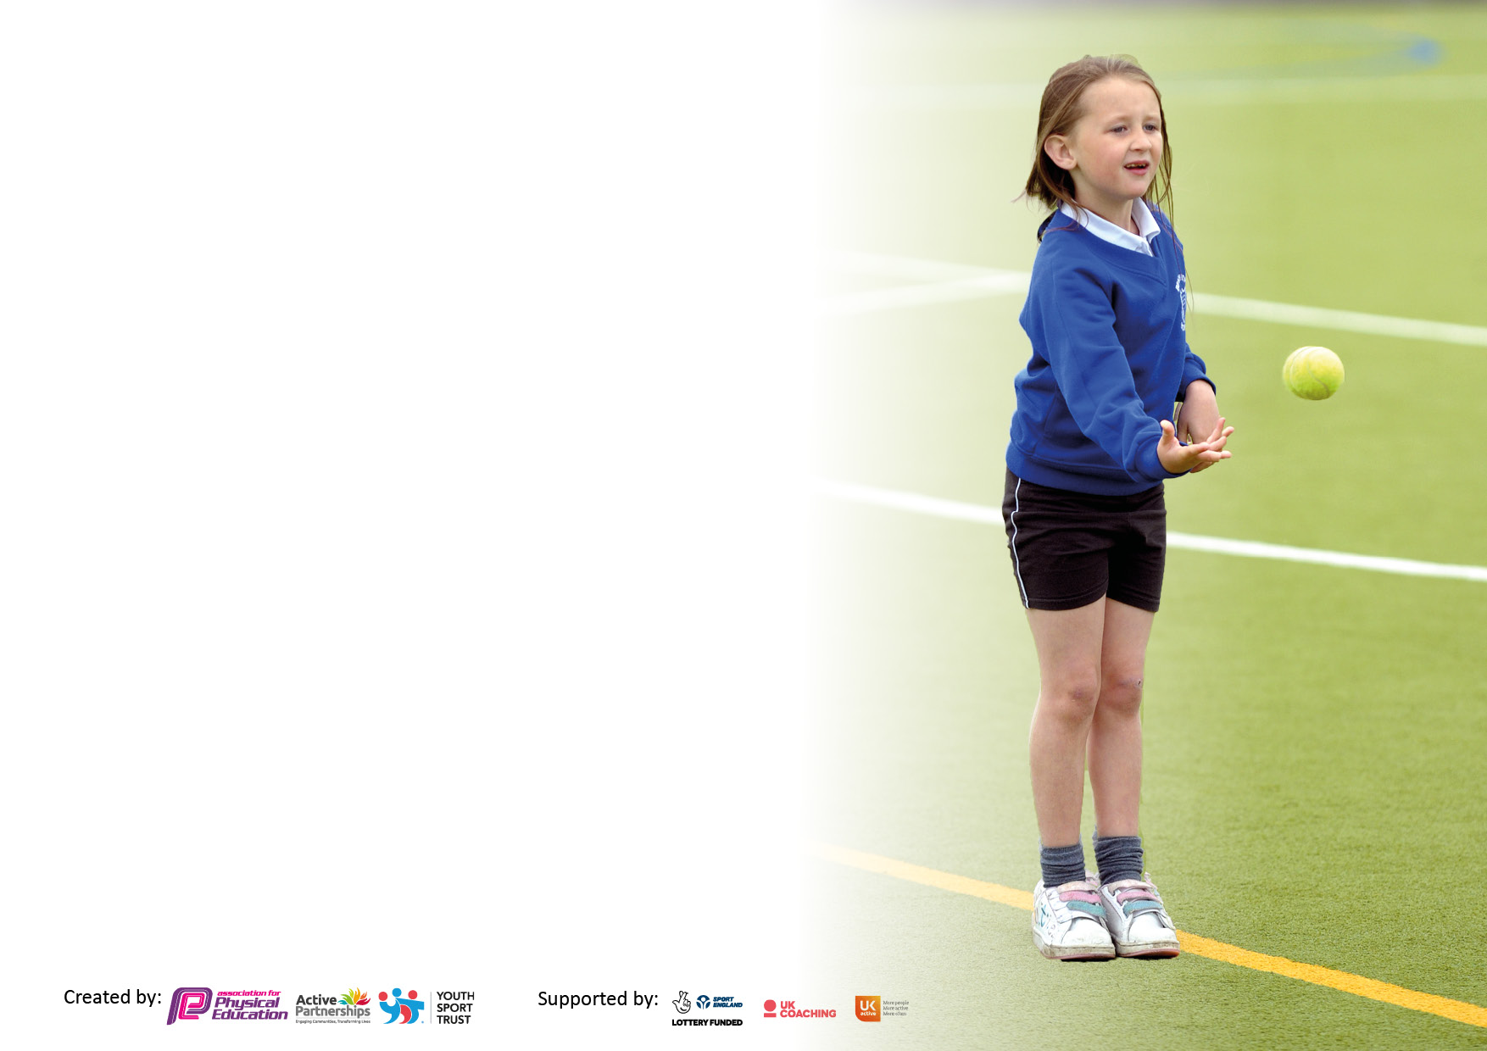

It is important that your grant is used effectively and based on school need. The Education Inspection Framework makes clear there will be a focus on ‘whether leaders and those responsible for governors all understand their respective roles and perform these in a way that enhances the effectiveness of the school’.

Under the Quality of Education Ofsted inspectors consider:
Intent - Curriculum design, coverage and appropriateness
Implementation - Curriculum delivery, Teaching (pedagogy) and Assessment
Impact - Attainment and progress

To assist schools with common transferable language this template has been developed to utilise the same three headings which should make your plans easily transferable between working documents.

Schools must use the funding to make additional and sustainable improvements to the quality of Physical Education, School Sport and Physical Activity (PESSPA) they offer. This means that you should use the Primary PE and sport premium to:

- Develop or add to the PESSPA activities that your school already offer
- Build capacity and capability within the school to ensure that improvements made now will benefit pupils joining the school in future years
- The Primary PE and sport premium should not be used to fund capital spend projects; the school’s budget should fund these.

Pleasevisitgov.ukfortherevisedDfEguidanceincludingthe5keyindicatorsacrosswhichschoolsshoulddemonstrate animprovement.Thisdocumentwillhelpyoutoreviewyourprovisionandtoreportyourspend.DfEencouragesschools to use this template as an effective way of meeting the reporting requirements of the Primary PE and sport premium.

We recommend you start by reflecting on the impact of current provision and reviewing the previous spend.

Schools are required to publish details of how they spend this funding, including any under-spend from 2021/2022, as well as on the impact it has on pupils’ PE and sport participation and attainment. All funding must be spent by 31st July 2023.

We recommend regularly updating the table and publishing it on your website throughout the year. This evidences your ongoing self-evaluation of how you are using the funding to secure maximum, sustainable impact. Final copy must be posted on your website by the end of the academic year and no later than the 31st July 2023. To see an example of how to complete the table please click HERE.
Created by: Supported by:

Details with regard to funding
Please complete the table below.

Total amount carried over from 2021/2022 | £1,420
Total amount allocated for 2022/2023 | £17,150
How much (if any) do you intend to carry over from this total fund into 2023/2024? | £0.00
Total amount allocated for 2023/2024 | £ 14,301
Total amount of funding for 2023/2024. To be spent and reported on by 31st July 2024. | £ 14,301
+

Meeting national curriculum requirements for swimming and water safety.  N.B. Complete this section to your best ability. For example you might have practised safe self-rescue techniques on dry land which you can then transfer to the pool when school swimming restarts.  Due to exceptional circumstances priority should be given to ensuring that pupils can perform safe self-rescue even if they do not fully meet the first two requirements of the NC programme of study | Barcombe’s Key Stage Two pupils received swimming tuition at Cumnor House swimming pool in 2022/2023.
What percentage of your current Year 6 cohort can swim competently, confidently and proficiently over a distance of at least 25 metres?  N.B. Even though your pupils may swim in another year please report on their attainment on leaving primary school at the end of the summer term 2023.  Please see note above | At the end of the academic year 2022/2023, 79% of Year 6 could swim over a distance of 25 metres.
What percentage of your current Year 6 cohort can use a range of strokes effectively [for example, front crawl, backstroke and breaststroke]?  Please see note above | At the end of the academic year 2022/2023, 79% of Year 6 could use a range of strokes effectively.
What percentage of your current Year 6 cohort perform safe self-rescue in different water-based situations? | 42% could perform safe self-rescue in different water-based situations.
Schools can choose to use the Primary PE and sport premium to provide additional provision for swimming but this must be for activity over and above the national curriculum requirements. Have you used it in this way? | No

Action Plan and Budget Tracking
Capture your intended annual spend against the 5 key indicators. Clarify the success criteria and evidence of impact that you intend to measure to evaluate for pupils today and for the future.

Academic Year: 2022/2023 | Total fund allocated:£20,836 | Date Updated: July 2023
Key indicator 1: The engagement of all pupils in regular physical activity – Chief Medical Officers guidelines recommend that primary school pupils undertake at least 30 minutes of physical activity a day in school |  |  |  | Percentage of total allocation:
 |  |  |  | 37.61%
Intent | Implementation |  | Impact
Your school focus should be clear what you want the pupils to know and be able to do and about  what they need to learn and to  consolidate through practice: | Make sure your actions to achieve are linked to your intentions: | Funding allocated: |  | Sustainability and suggested next steps:
Provide a wide range of activities within the curriculum and at break/lunchtimes.  Continue to develop zones on the playground at lunchtimes to encourage physical activity.  Ensure all classes are taking part in the Daily Mile Challenge. Vary the approach to the Daily Mile  Increase the range of before and after school activities, offering more places for children (including SEN and Pupil Premium). | Invest in play equipment to promote regular physical activity for all children at break/lunchtimes.  All classes have an indoor and outdoor PE timetable with allocated slots on rotation (including for equipment) for each term.  Daily Mile Challenge timetable.  On-going staff training to enhance range of activities available; activities to include all children.  Develop use of outside activity trim trail and bouldering/traversing wall. | £1,319(Equipment and Resources)  £5,370 (Sports Coaches-Sports Cool)  £295 (Skipping day) | Children are more motivated to participate in physical activities during ‘free’ time, building on skills acquired during PE lessons.  Morning sessions support an active, purposeful start to the school day.  At lunchtimes children have focused physical activities including outdoor gym equipment, skipping ropes, trim trails, and hand/eye co-ordination tasks.  More clubs on offer and at different times during the week to provide increased opportunities for all children.  Staff more confident in delivery. | Continue to offer a range of activities throughout the day-before school, after school, lunchtimes and break times.  Ensure that new staff are trained and equipped to lead activities.  Continue to increase the range of equipment available for all children to use. Also, maintain the existing equipment.  Develop the role of sports leaders with Sports Cool to increase engagement, pupil voice and early leadership skills  Opportunity for Pupil Voice; focus on ‘seldom heard’ pupils.
Key indicator 2: The profile of PESSPA being raised across the school as a tool for whole school improvement |  |  |  | Percentage of total allocation:
 |  |  |  | 2.27%
Intent | Implementation |  | Impact
Your school focus should be clear what you want the pupils to know and be able to do and about  what they need to learn and to  consolidate through practice: | Make sure your actions to achieve are linked to your intentions: | Funding allocated: | Evidence of impact: what do pupils now know and what they can now do? What has changed? | Sustainability and suggested next steps:
Ensure that school sporting achievements are recognised.  Celebrate achievements of pupils both in and out of school; children understand that their achievements are valued by all.  Role models in sporting fields to inspire and encourage goals and aspirations in children.  Children are informed of local, national and global sporting events – for example attending Eastbourne International Tennis tournament | Continue to utilise PE working wall in the communal area. Continue to ensure that this features contributions from all groups. Emphasis on the aspects of PE that promote development in personal, social, cognitive, creative, physical and health/fitness skills and awareness.  Weekly assemblies provide the chance for children to share sporting achievements.  Virtually or face to face, invite local sports ‘stars’ to talk about their successes and achievements, and promote their sports. | £422 Eastbourne Tennis & Gala | Children are proud to share their achievements and are keen to share what they have done out of school.  Children can articulate how they feel about bringing in their awards. Children can articulate why it is important to celebrate everyone’s sporting achievements.  Children have more aspirational goals with regard to sport.  Children’s confidence and self-esteem are raised; this has an impact on learning throughout the curriculum. | Continue to share achievements in celebration assemblies.  Reach out to local sports stars/past pupils who have success stories to share.  Begin encouraging children to write reports on sports events they have participated in or watched and share these on the communal noticeboard.  Continue to raise the profile of sport for all children.

Key indicator 3: Increased confidence, knowledge and skills of all staff in teaching PE and sport |  |  |  | Percentage of total allocation:
 |  |  |  | 28.92%
Intent | Implementation |  | Impact
Your school focus should be clear | Make sure your actions to | Funding | Evidence of impact: what do | Sustainability and suggested
what you want the pupils to know | achieve are linked to your | allocated: | pupils now know and what | next steps:
and be able to do and about | intentions: |  | Can they do now? What has
what they need to learn and to |  |  | changed?
consolidate through practice:
Continue to increase the skill set of all staff.  Ensure that all PE teaching is at least good (with the aim for outstanding).  Ensure that progress is at least good for ALL pupils.  Continuing development of the PE Co-ordinator’s leadership through facilitation of sporting events, CPD and coaching with Sports Cool to increase the quality of provision for all pupils. | All teachers to receive CPD in the area of PE, with a focus on ECTs and staff new to Barcombe.  Primary PE specialist/Sports Coach will work alongside teachers to deliver curriculum content, with the expectation that teachers use this to develop their own skills. Teachers to work with Sports Cool coaches.  Purchase of PE equipment to ensure that lessons are well-resourced and progressive. | £5370 (Sports Cool Coaches) [see Key Indicator 1] | Planning and assessment of PE and sports opportunities is robust and moves children’s learning forward. Colleagues’ confidence with PE continues to improve.  Working with Sports Cool enhances the provision and experience for the pupils and, also, ensures that the teaching staff benefit from CPD. There are opportunities for staff to observe and then deliver sessions and gain feedback.  As a team, we work with the specialist to build up PE curriculum mapping to ensure breadth and coverage, as well as skill progression.  Pupils are more active in PE lessons.  Teachers are more positive and confident when delivering PE lessons.  Assessment in PE is becoming more secure. | Ongoing commitment to PE to continue to increase staff confidence and children’s skill development.  Enhanced focus on development of assessment.  Continue to focus on outcomes/weaknesses that Healthy Schools Award highlighted - a valuable audit of progress to date and an up to date action plan.
Key indicator 4: Broader experience of a range of sports and activities offered to all pupils |  |  |  | Percentage of total allocation:
 |  |  |  | 69.63%
Intent | Implementation |  | Impact
Your school focus should be clear | Make sure your actions to | Funding | Evidence of impact: what do | Sustainability and suggested
what you want the pupils to know | achieve are linked to your | allocated: | pupils now know and what | next steps:
and be able to do and about | intentions: |  | can they now do? What has
what they need to learn and to |  |  | changed?
consolidate through practice:
Additional achievements:  To increase the range of extra-curricular activities on offer.  Broaden the times of day when activities are offered.  To promote a love of sport and encourage all children to participate in extra-curricular activities.  Children to continue to explore active, outdoor learning and ways of working collaboratively. | Continue to offer a range of activities, both within and beyond the curriculum, in order to get more pupils involved. Focus on pupils who do not take up additional PE and sport opportunities. Outdoor classroom used for physical activity.  Keep registers of pupils attending sessions  Introduce activities before school, as well as after school.  Make links with local sports clubs, agencies etc. to see if they can support with offering different activities-during curriculum time and as extra-curricular opportunities.  Continue to develop and retain Forest School staff team.  Develop dance opportunities for Barcombe CE School.  After school clubs advertised and promote, regularly, in school newsletters. | £2,126 (Gardening)  £6957(Forest School Leader)  £1,190 (Dance Leader)  £2,657 (Activity trips offsite) | An exciting array of weekly sports clubs (before and after school): football; yoga; dance; karate; tennis; gardening.  Links have been made with local sports clubs/activity agencies to provide extra-curricular opportunities.  Pupils are more positive about a range of sports and outdoor activities.  Increased number of pupils taking part in extra-curricular clubs.  More children joining clubs for evening and weekend sessions. | Continue to ensure that a range of activities are offered.  Subject leader to monitor the curriculum planning.  Subject leader to monitor the extra-curricular clubs on offer and keep register.  Continue to make links with external clubs in the local area.  Ensure that all staff support providing a range of activities for all children.  Ensure that PP children are being offered and encouraged to take up activities.

Key indicator 5: Increased participation in competitive sport |  |  |  | Percentage of total allocation:
 |  |  |  | 2.69%
Intent | Implementation |  | Impact
Your school focus should be clear | Make sure your actions to | Funding | Evidence of impact: what do | Sustainability and suggested
what you want the pupils to know | achieve are linked to your | allocated: | pupils now know and what | next steps:
and be able to do and about | intentions: |  | can they now do? What has
what they need to learn and to |  |  | changed?
consolidate through practice:
Increase the number of pupils taking part in competitive sports and representing the school.  Ensure that a wider range of ALL pupils have opportunities to represent the school.  Instil a respect, responsibility and aspiration through competitive sport. | Increased participation through the local Primary Sports Partnership and inter federation sporting events.  Additional competitive sports to be identified in order to engage more pupils – focus on dance and gymnastics  Continue to liaise with Chailey School to investigate which tournaments are being organised.  Successful Sports Day held in July 2023. | £500 | Children become better equipped with skills and self-confidence to compete in a range of sporting activities.  Sporting achievements relating to a range of competitions are celebrated via assemblies and the weekly bulletin.  Children apply sporting attributes to their everyday lives, both in school and out of school – especially building transferable resilience.  Children’s resilience and enjoyment of competitive sport continues to increase.  More children keen to participate. | Continue to maintain link with Chailey School and the Primary Sports Partnership.  Organise Skylark Federation inter-school competitions every 2/3 weeks  Multi-skills opportunity for Key Stage One pupils at Wivelsfield Primary School and greater Federation opportunities for Reception and KS1  Investigate other competitive events in the wider community (Brighton mini Half Marathon, for example).

Signed off by
Head Teacher:
Date:
Subject Leader:
Date:
Governor:
Date:

