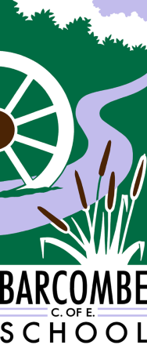
Barcombe Bubble After School Club
Booking Form:
Child’s Name:__________________________________________

Child’s Class:__________________________________________

Cost for bookings made and paid for by the end of the previous week.
- Full Session 3.15 - 5.30pm £10.00 per session,
- Half Session 3.15 - 4.30pm £5.00 per session
- Following a school club 4.00-5.30pm £5.70 per session

For ad hoc sessions, if available, (not booked or paid for the previous week)
- Full Session 3.15 - 5.30pm £11.00 per session
- Half Session 3.15 - 4.30pm £5.50 per session
- Following a school club - 4.00 - 5.30pm £6.60 per session

I would like to book a REGULAR place each week on the following day/s, from the following date:
PLEASE STATE PICK UP TIME
Please tick:
Monday | Tuesday | Wednesday | Thursday

I would like to request a place at the After School Club on the following date/dates: (PLEASE STATE PICK UP TIME)
……………………………………………………………………………………………………………………
……………………………………………………………………………………………………………………
…………………………………………………………………………………………………………………… I confirm that I agree to abide by the Terms and Conditions on the Parent/Carer Information Leaflet.
Signed…………………………………………………… Date……………………………………….

