Welcome to Hedgehog Class
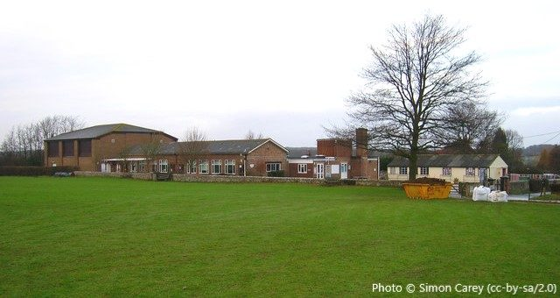
At Barcombe School

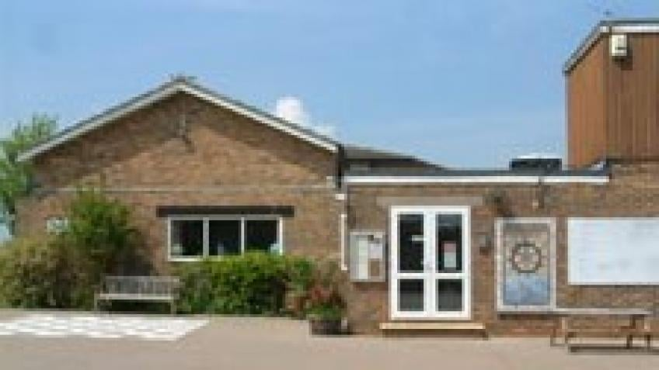

Meet your teachers
Miss Eaglen and Mrs Hills
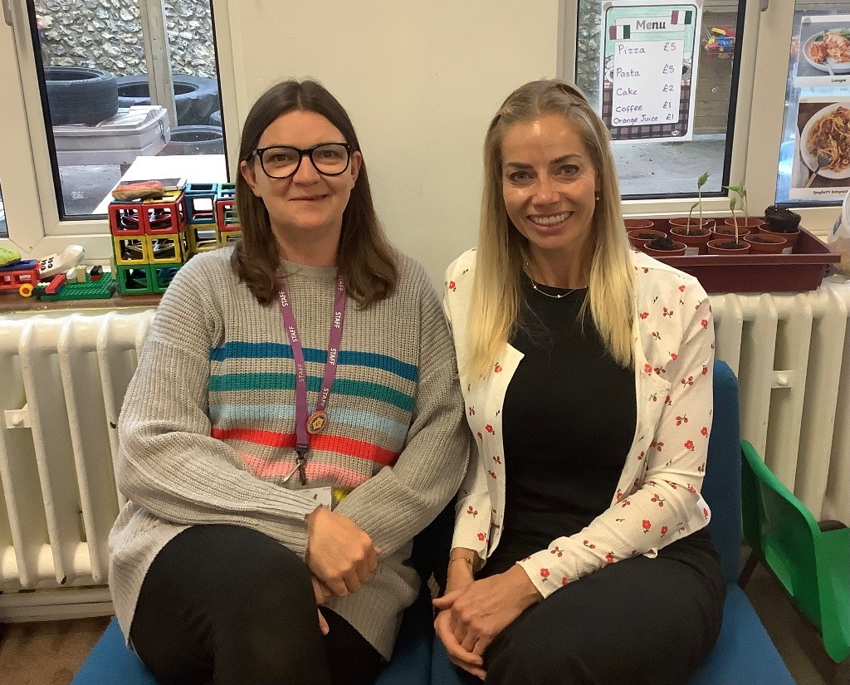
This is what we wear for school.
We have school uniform and a book bag.
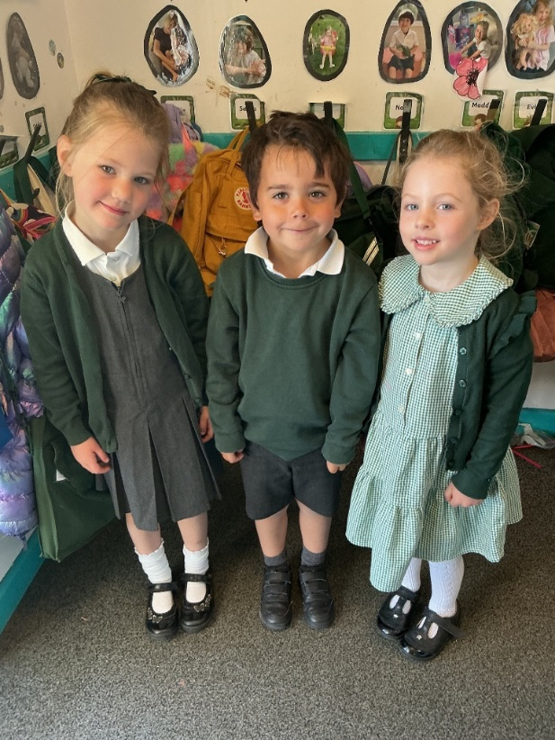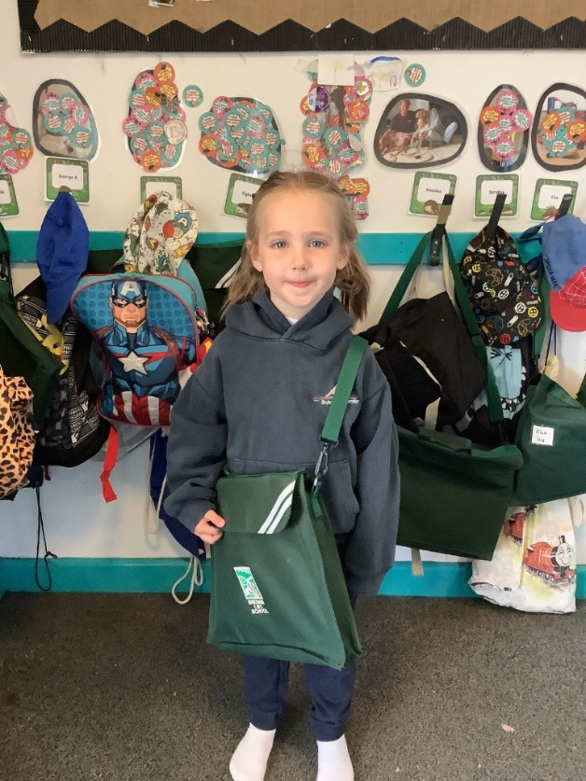
On PE days we wear our PE kit.
This is the cloak room.
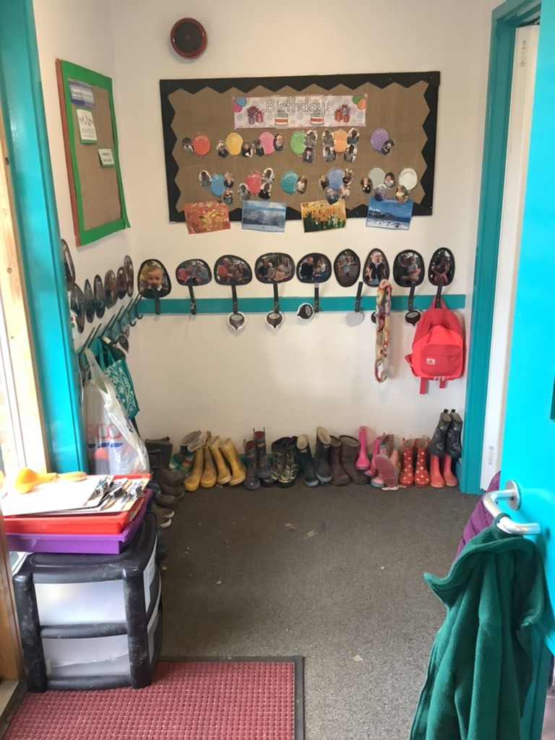
We hang our coats on our peg and leave our welly boots underneath.
We always go out for a walk on Wednesdays and Fridays.

Snack time
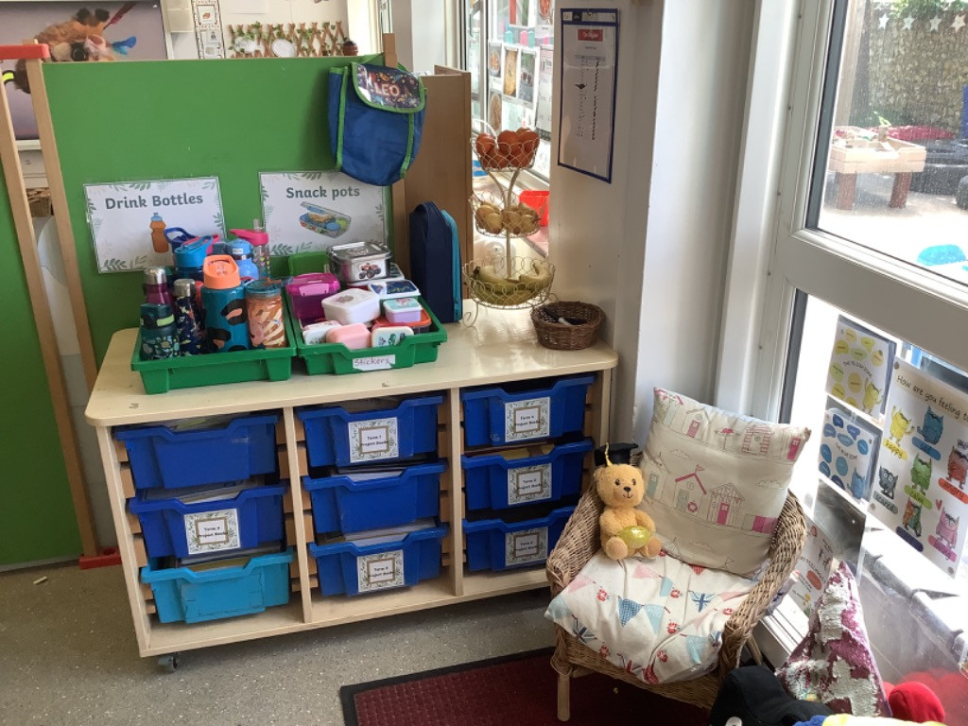
We put our water bottles and snacks here.

We have a fruit bowl to choose snacks from every morning.

These are our toilets.
They are nice and small for us to use.
Can you see any sea creatures in our toilets?
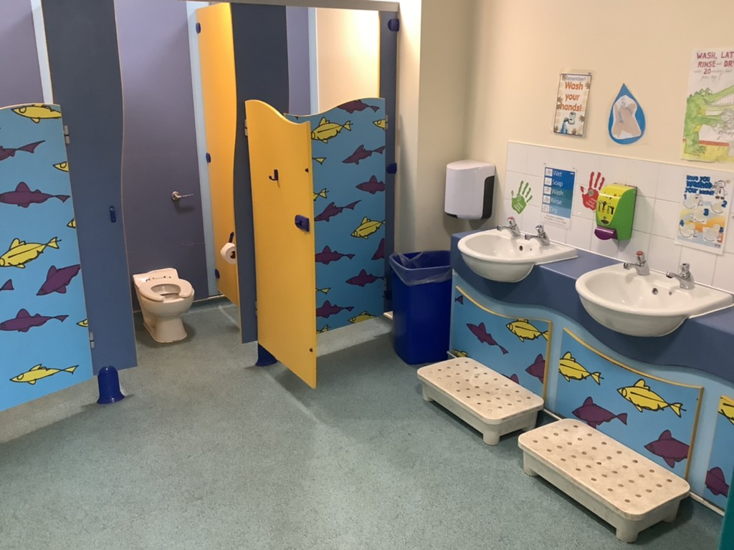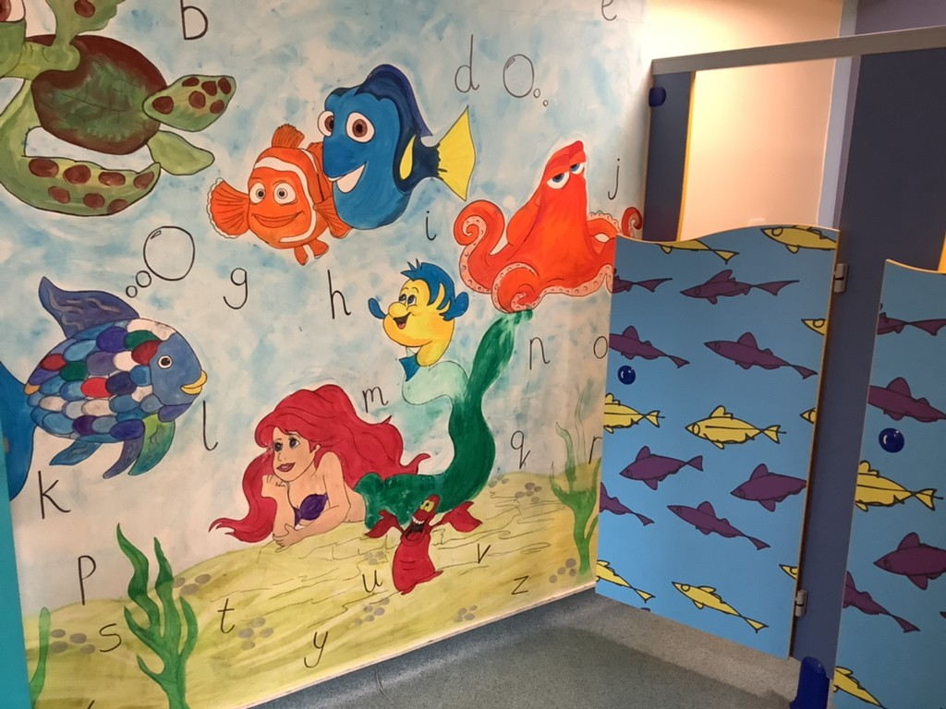
This is our role play home corner. We like to dress up and look in the mirror.
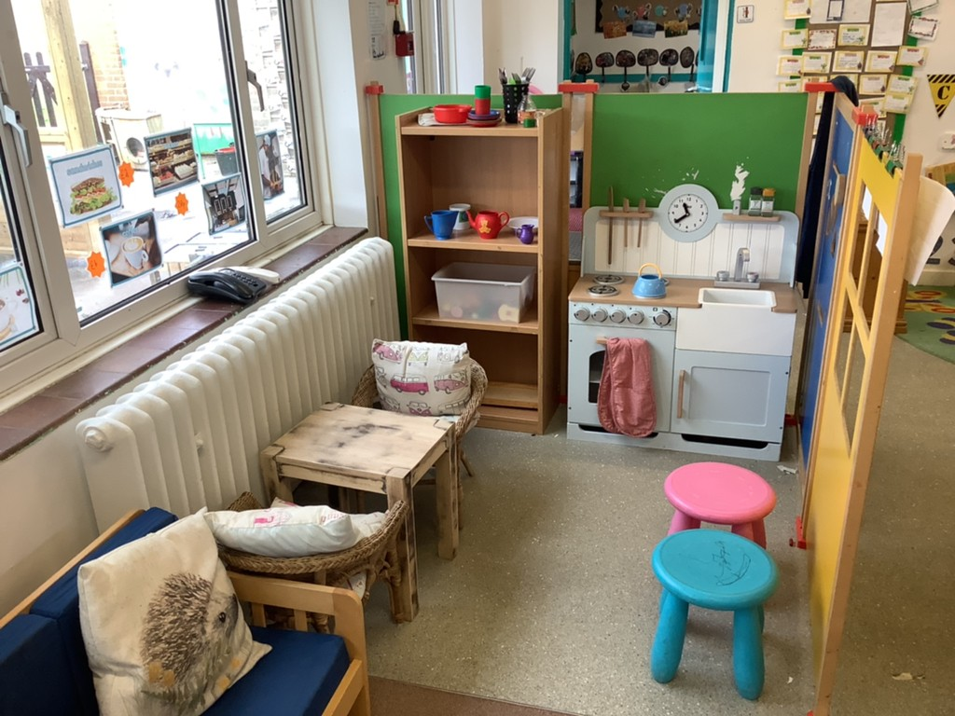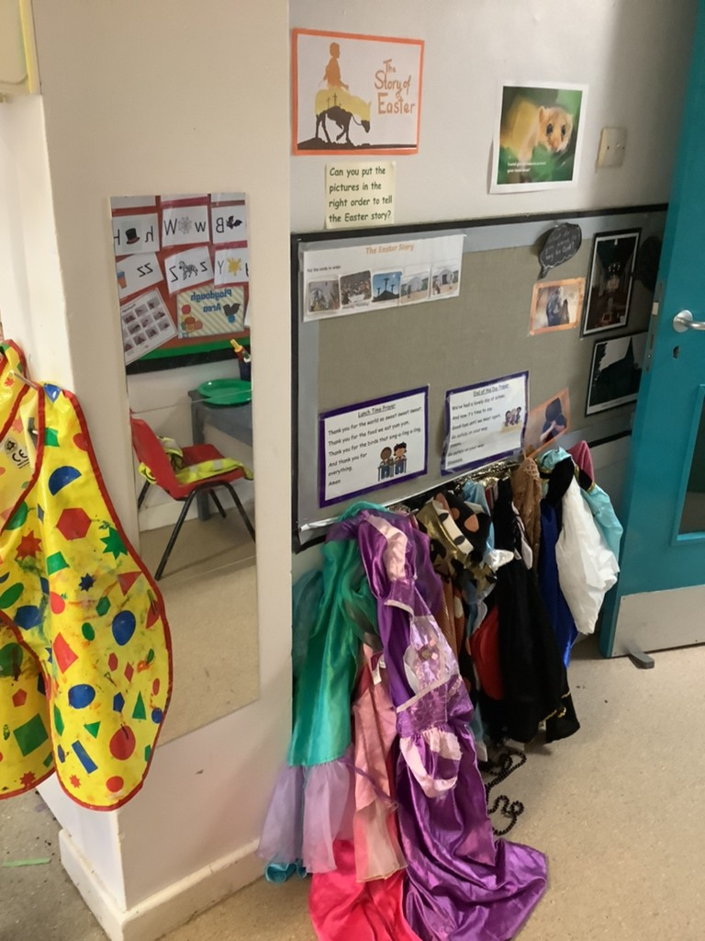
We love to build with the different construction kits and loose parts.
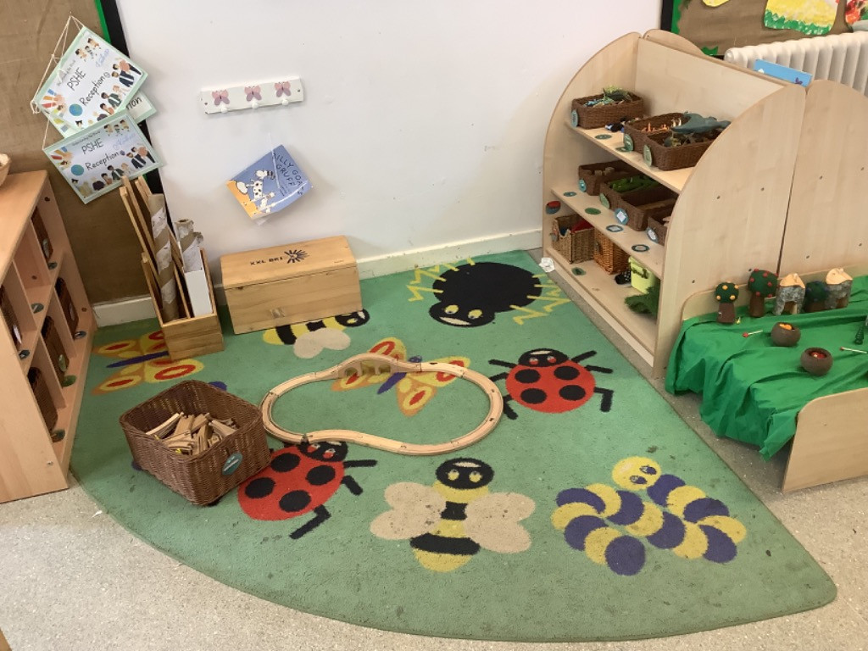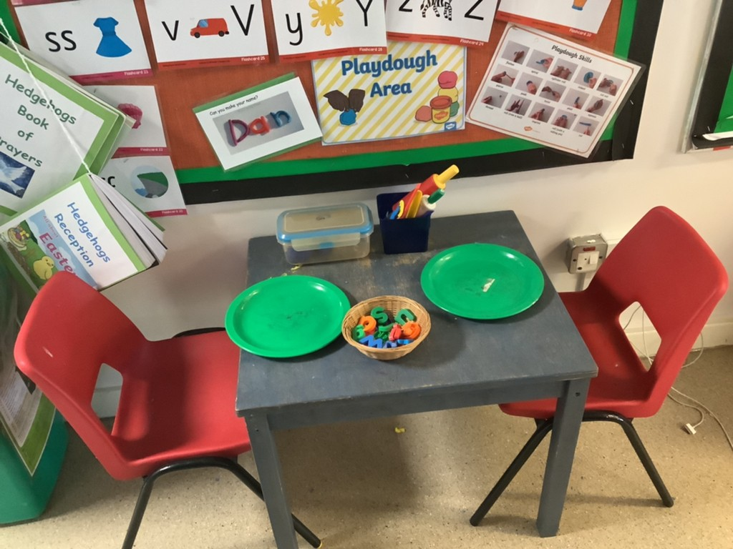
This is our playdough table. We use the tools and hands with the dough.
This is our cosy book corner. We can get comfortable and relax with a book and a bear.
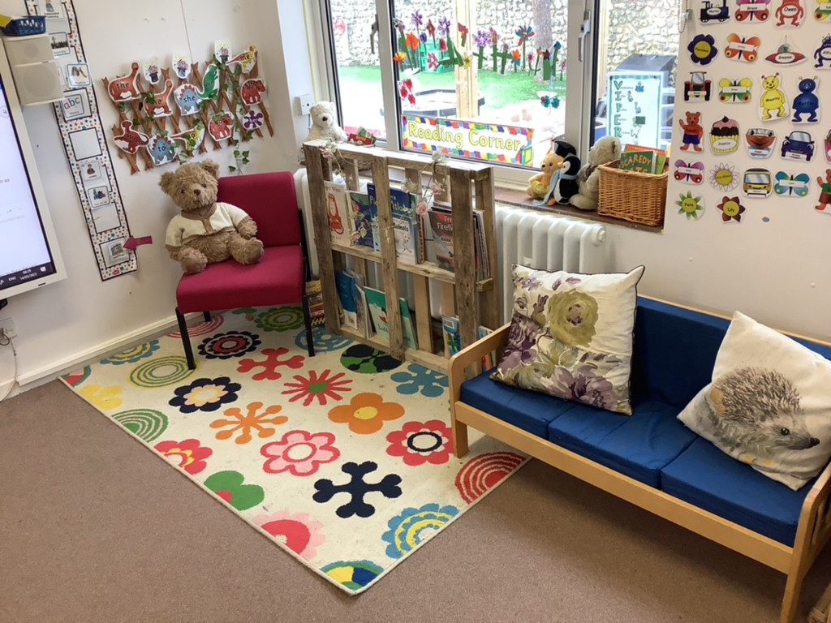
We love to draw and use pens and pencils in the message centre.
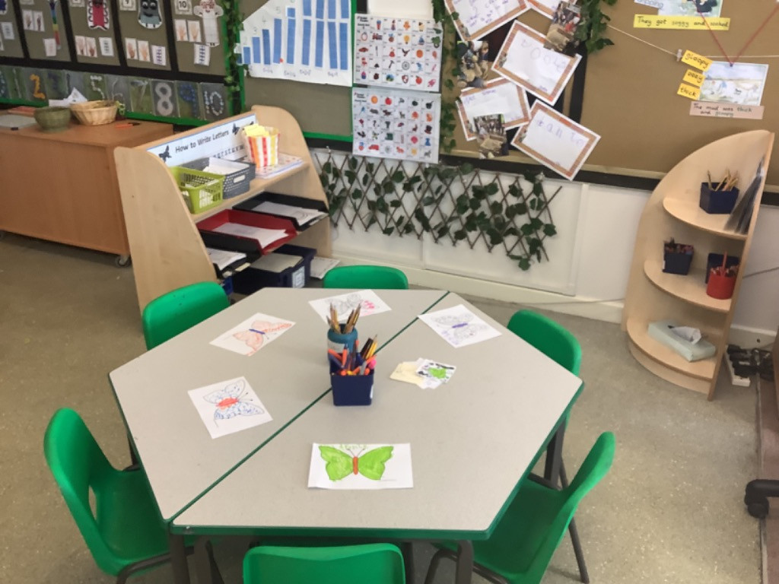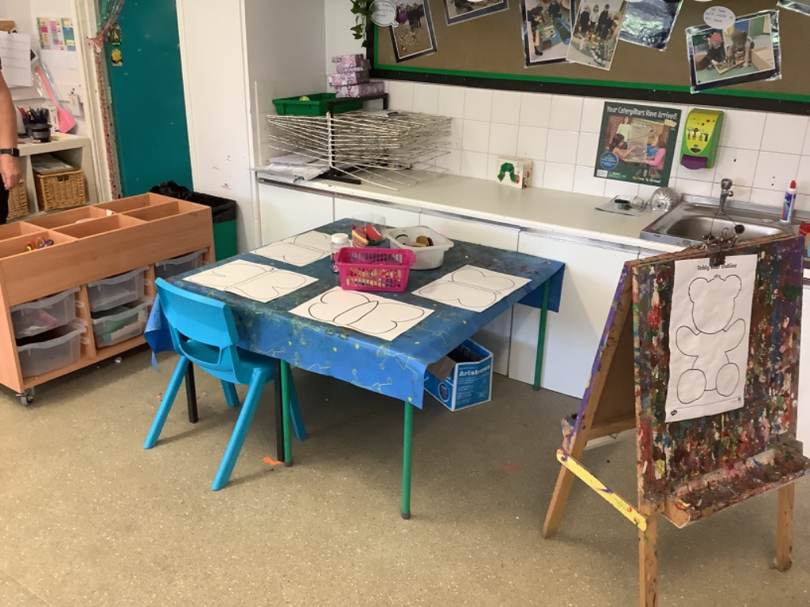
This is our creative corner, where we can paint and make things.
This is the sports hall.
We go in here for PE so we can run and play games. We also go in here to eat our lunch.
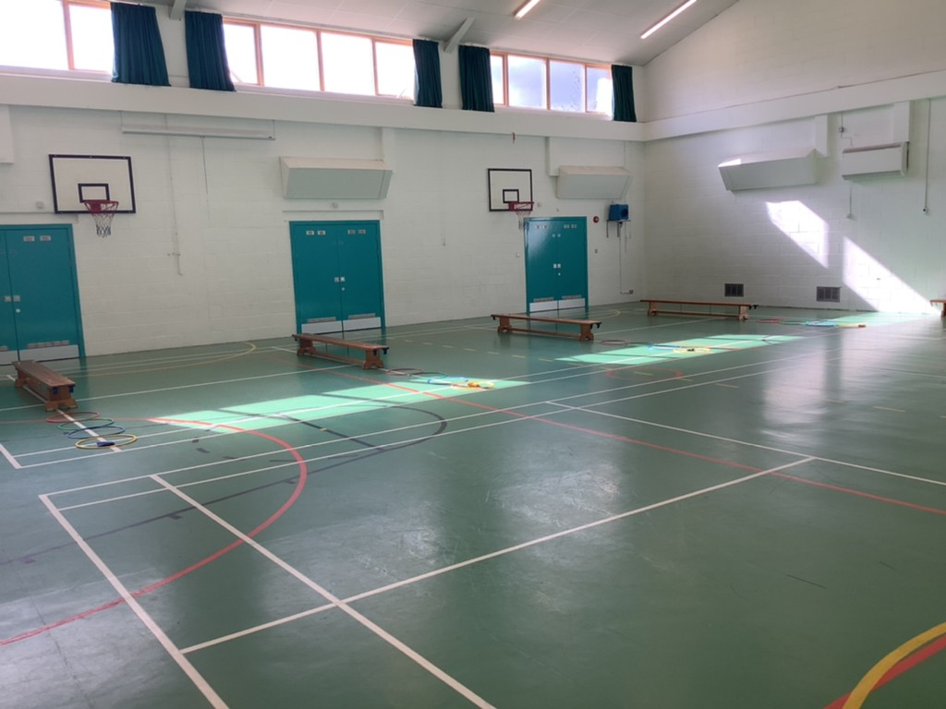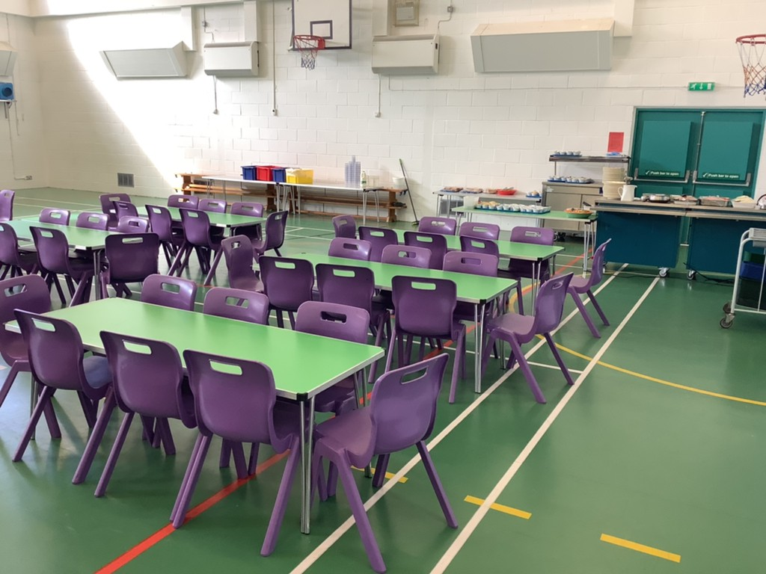

This is Hedgehog Garden. We like to play in the water tray and sand pit.
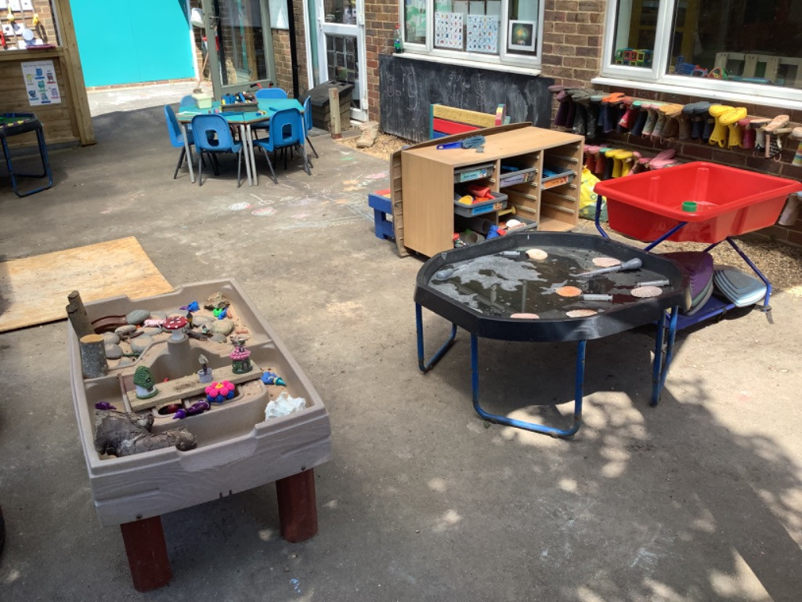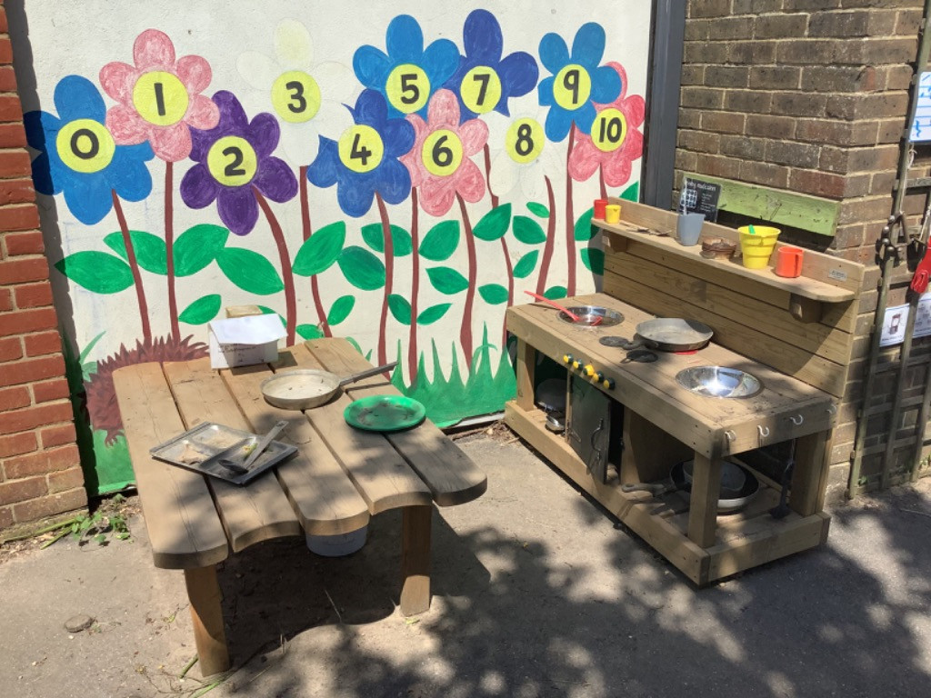
We like to mix up recipes in the mud kitchen.

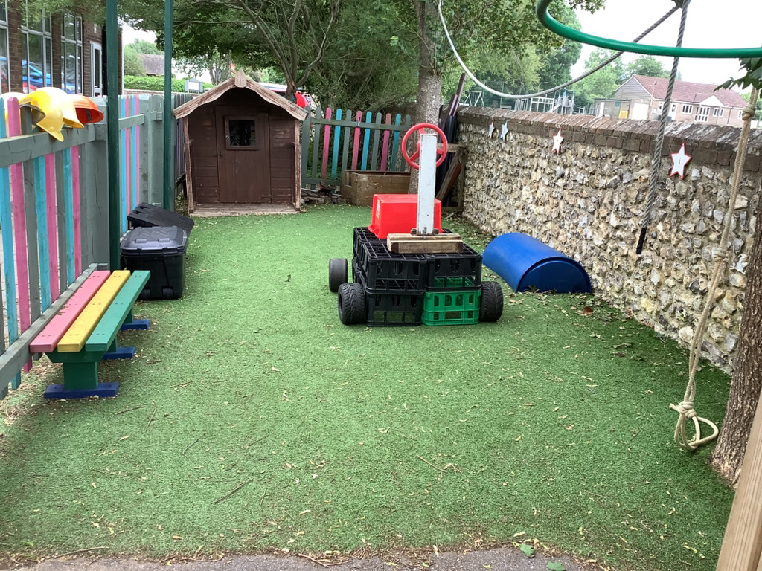
This is our big building area. We can use tyres, crates, planks, wheels to make things!
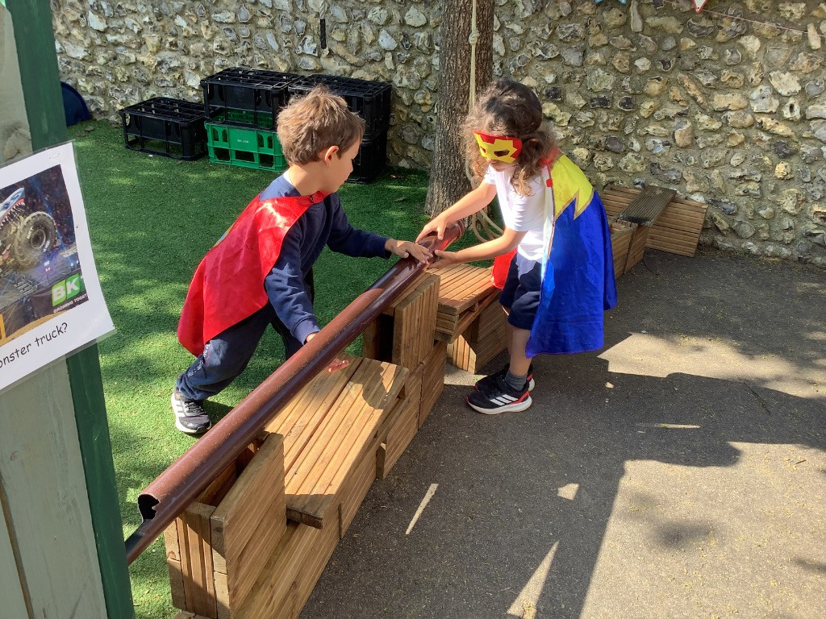

We can also build things in the small building tray.
This is our playground where we play after lunch.
Your buddy will help you find your way around and climb the trail!
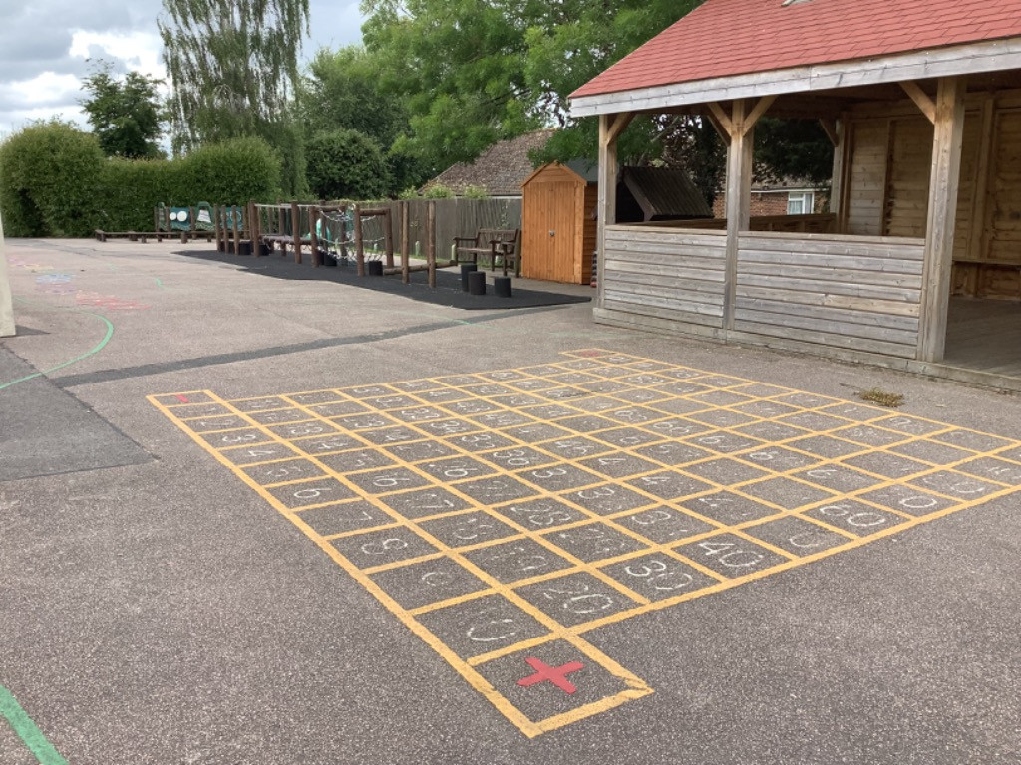
I look forward to seeing you all for story time in Hedgehog class soon!
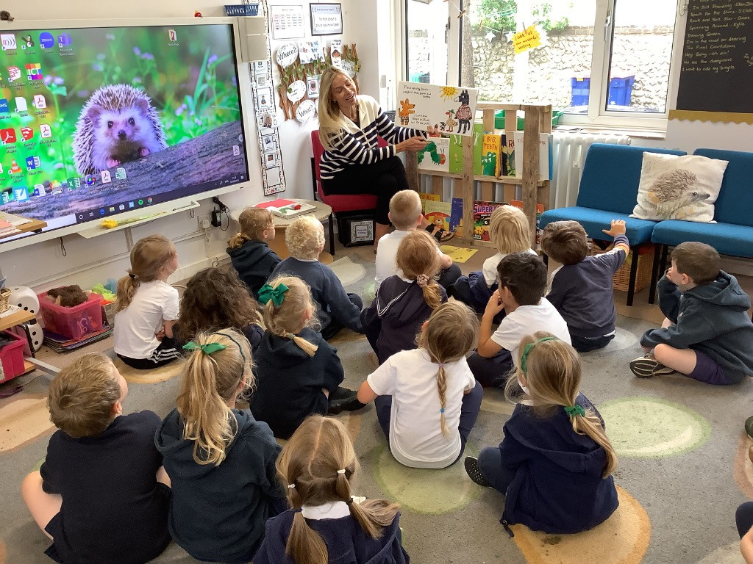
From Miss Eaglen

